**E-Project: Star Brand**

STAR BRAND

|  |  |  |
| --- | --- | --- |
| **Supervisor.** | Sir Shakir Khan | |
| **Batch.** | 2305E1 | |
| **Group.** | 02 | |
| **Serial No.** | **Enrollment No.** | **Student Name** |
| 1. | Student1478236 | Atta Muhammad |
| 2. | Student1478241 | Hassan ullah |
| 3. | Student1477700 | Aniqa Tauseef |
|  |  |  |

ACKNOWLEDGEMENT

The first, we would like to express our special thanks of gratitude to our teacher **Sir Shakir Khan**, who helped us a lot in finalizing this project within the limited time frame, valuable counselling and assistance for the accomplishment of this project.

Secondly we would also like to thank the eProject team at Aptech Head Office, who gave us the golden opportunity to do this wonderful project about Star Brand.

Thirdly, we also thank the eProject team, some of the benefits are as under:

* Re-enforcement of skills happens in the experiential learning process.
* A mentor, ensuring that we do not get drifted, constantly guides us.
* It gives us a lot of confidence to face an interview as we have worked on a project. We can explain virtually everything on the subject we have learnt.

SYNOPSIS

Follow the strong development of the internet, and the growing food market, every business needs a website design to display products on the internet.

The following Star Brand menu are made with many different varieties, suitable for all age group and preferences.

So Star Brand shares it’s best selling Spices through the website for everyone to know.

However, purchases are made directly on the website.

PROBLEM DEFINITION

Star Organic farm is commenced in the year 1988. Company is involved in tradingand manufacturing a wide range of Organic Products and spices to the consumers’ all around the global market. Company has wide variety of collection of products lies of ***Nutritious cereals, Pulses, Spices and Condiments, Cooking Oils, Fruit Pulps,Agro Products, Oils, Wheat and Wheat Flour, Rice and Rice products and so on***.

*1. User-Friendly Navigation:*

**Implement a user-friendly navigation system that categorizes spices, herbs, blends, and recipes into clear and intuitive sections.**

**Create a drop-down menu for easy access to different spice categories (e.g., herbs, ground spices, whole spices) and cuisines.**

**Use clear, descriptive labels to make it easier for users to find what they're looking for.**

*2. Enhanced Search Functionality:*

**Implement a robust search feature that allows users to search for specific spices or recipes quickly.**

**Use filters, such as type of cuisine, dietary preferences, or specific health benefits to refine search results.**

*3. Spice Benefits Section:*

**Create a dedicated section on the website to educate users about the health benefits and culinary uses of various spices.**

**Include articles, infographics, or videos that explain how each spice can be incorporated into cooking and its potential health advantages.**

*4. Recipe Recommendations:*

**Implement a "Recommended Recipes" section on the homepage, which offers users a variety of recipes featuring different spices.**

**Allow users to filter recipes by difficulty level, dietary restrictions, or cuisine type.**

*5. User Feedback Mechanism:*

**Encourage users to provide feedback through a user-friendly feedback form or survey.**

**Actively seek and consider user suggestions for improvements to the website, such as layout changes, additional content, or new features.**

*6. Mobile Optimization:*

**Ensure the website is responsive and optimized for mobile devices, making it accessible to a broader audience.**

*7. Regular Updates:*

**Commit to maintaining and updating the website regularly to keep content and information current and engaging for users.**

**Requirement Specification:**

The Web site is to be created based on the following requirements.

* The Home Page should be created making use of Sections with a suitable logo of STAR BRAND.
* Links such as Home, Products, Contact Us, Query, Show case gallery must be Included.
* The Products must be properly categorized and details of each product must
* be presented with suitable size image.
* For each information section of the products the enquiry and order link must be provided.
* Contact us page must be included.
* Navigation must be made smoother.
* Uniformity in the designing must be maintained in the application.
* Images must be defined with alt attribute defined.

**SCOPE OF THE WORK**

**The website is to be developed for the windows platform using HTML5, javascript and geolocation. The site should work well in all leading browsers including chrome, IE, Firefox etc….**

**Homepage show top best sell items, big deals, new shop…..**

**Every content direct to relative content.**

*FLOW CHART*

Query.html

Star Brand

(home.html)

Menu

(menu.html)

Careals.html

Spices.html

Fruitpulp.html

Wheat.html

Rice.html

Contact.html

Conta.html

About Us

(About.html)

Location

(location.html)

Gallery

(gallery.html)

Contactus.html

Conta.html

Fruitpulp.html

Contact

Contact.html

**PROGRESS DIAGRAM**

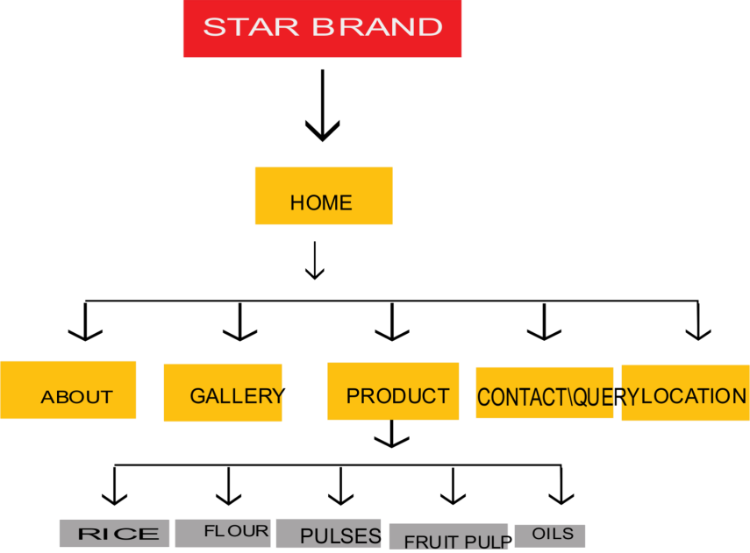

***Thank You For Reading The Documentation.***

***Please Follow The Instruction s Above !!***